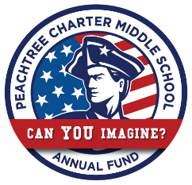
PCMS Finance Committee
Agenda: October 9, 2018

PCMS Conference Room, Main Floor, 7:30am

Welcome
Regular Business
- Public Comment- 3 minutes each
- Approval of Minutes
- Review Grant Requests
- Update – Previously Approved Gants
Financial Policies and Procedures
- Gant Objective
- IXL
Subcommittee Updates and Miscellaneous New Business
- Annual Fund
  - Box & Sign
  - Other
- CV Classic
  - PE Involvement
- School Store
- New Business
  - Village Orthodontics – Corporate Sponsorship

Adjournment, Next Meeting Tues. Nov 6, 2018

