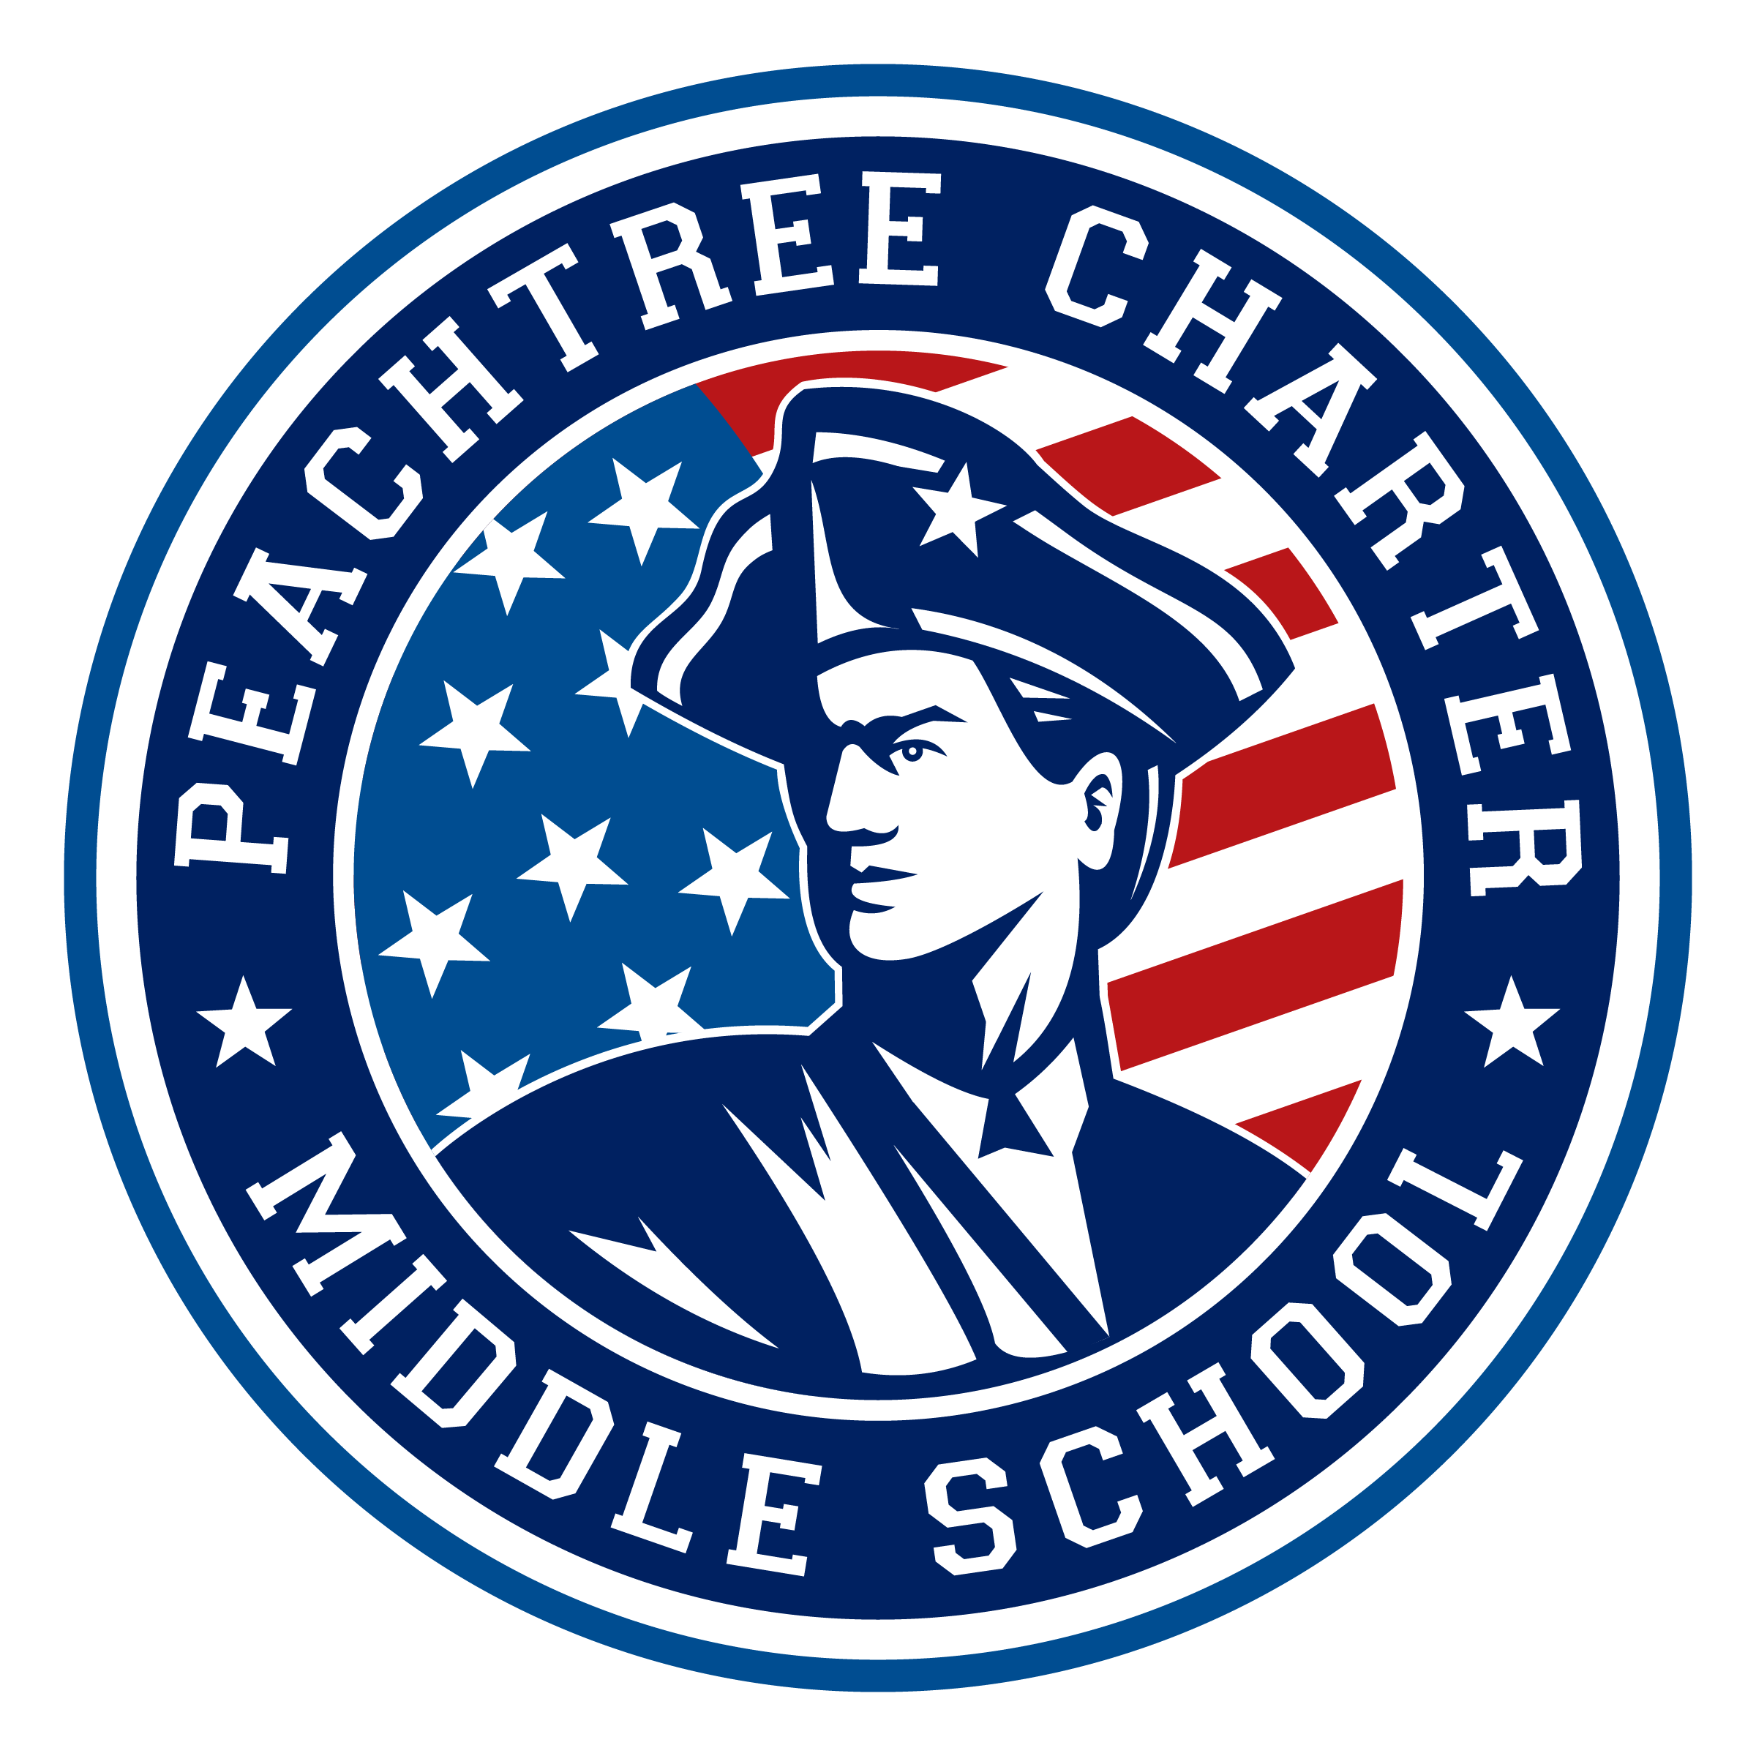

PCMS Foundation Governing Board Meeting

December Agenda

December 16, 2019

6:00 pm – PCMS Media Center
- Call to order
- Welcome
- Public Comment (3 minutes each)
- Co-Chair Report
    - Charter Interest Vote Update
- Approval of minutes from last meeting,
- Action Items from last meeting
- Financials
- Grant Requests
- Principal Report
- Committee Reports
  - Academics
  - Facilities & Hospitality
  - Finance
  - Regulatory
- Old Business & New Business
  - High Achievers – Allegra Johnson
  - Scheduling – Dr. Davis
  - CCRPI – Dr. Davis
  - Survey Results
- Adjournment
IMPORTANT DATES

DECEMBER
- December 19 – Charter Renewal Interest Vote
- December 23 – Winter Break Begins

Meeting Norms
- Maintain a focus on what is best for our students.
- Show respect (never dismiss/devalue others).
- Be willing to compromise.
- Disagree (when necessary) agreeably.
- Make a commitment to effective deliberation, each one listening with an open mind while others are allowed to express their points of view.
- Participate by building on the thoughts of a fellow Board member.
- Make a commitment to open communication and honesty.
- Commit the time necessary to govern effectively.
- Be collaborative.
- Maintain confidentiality (which leads to the building of trust).
- Look upon history as lessons learned; focus on the present and the future.

