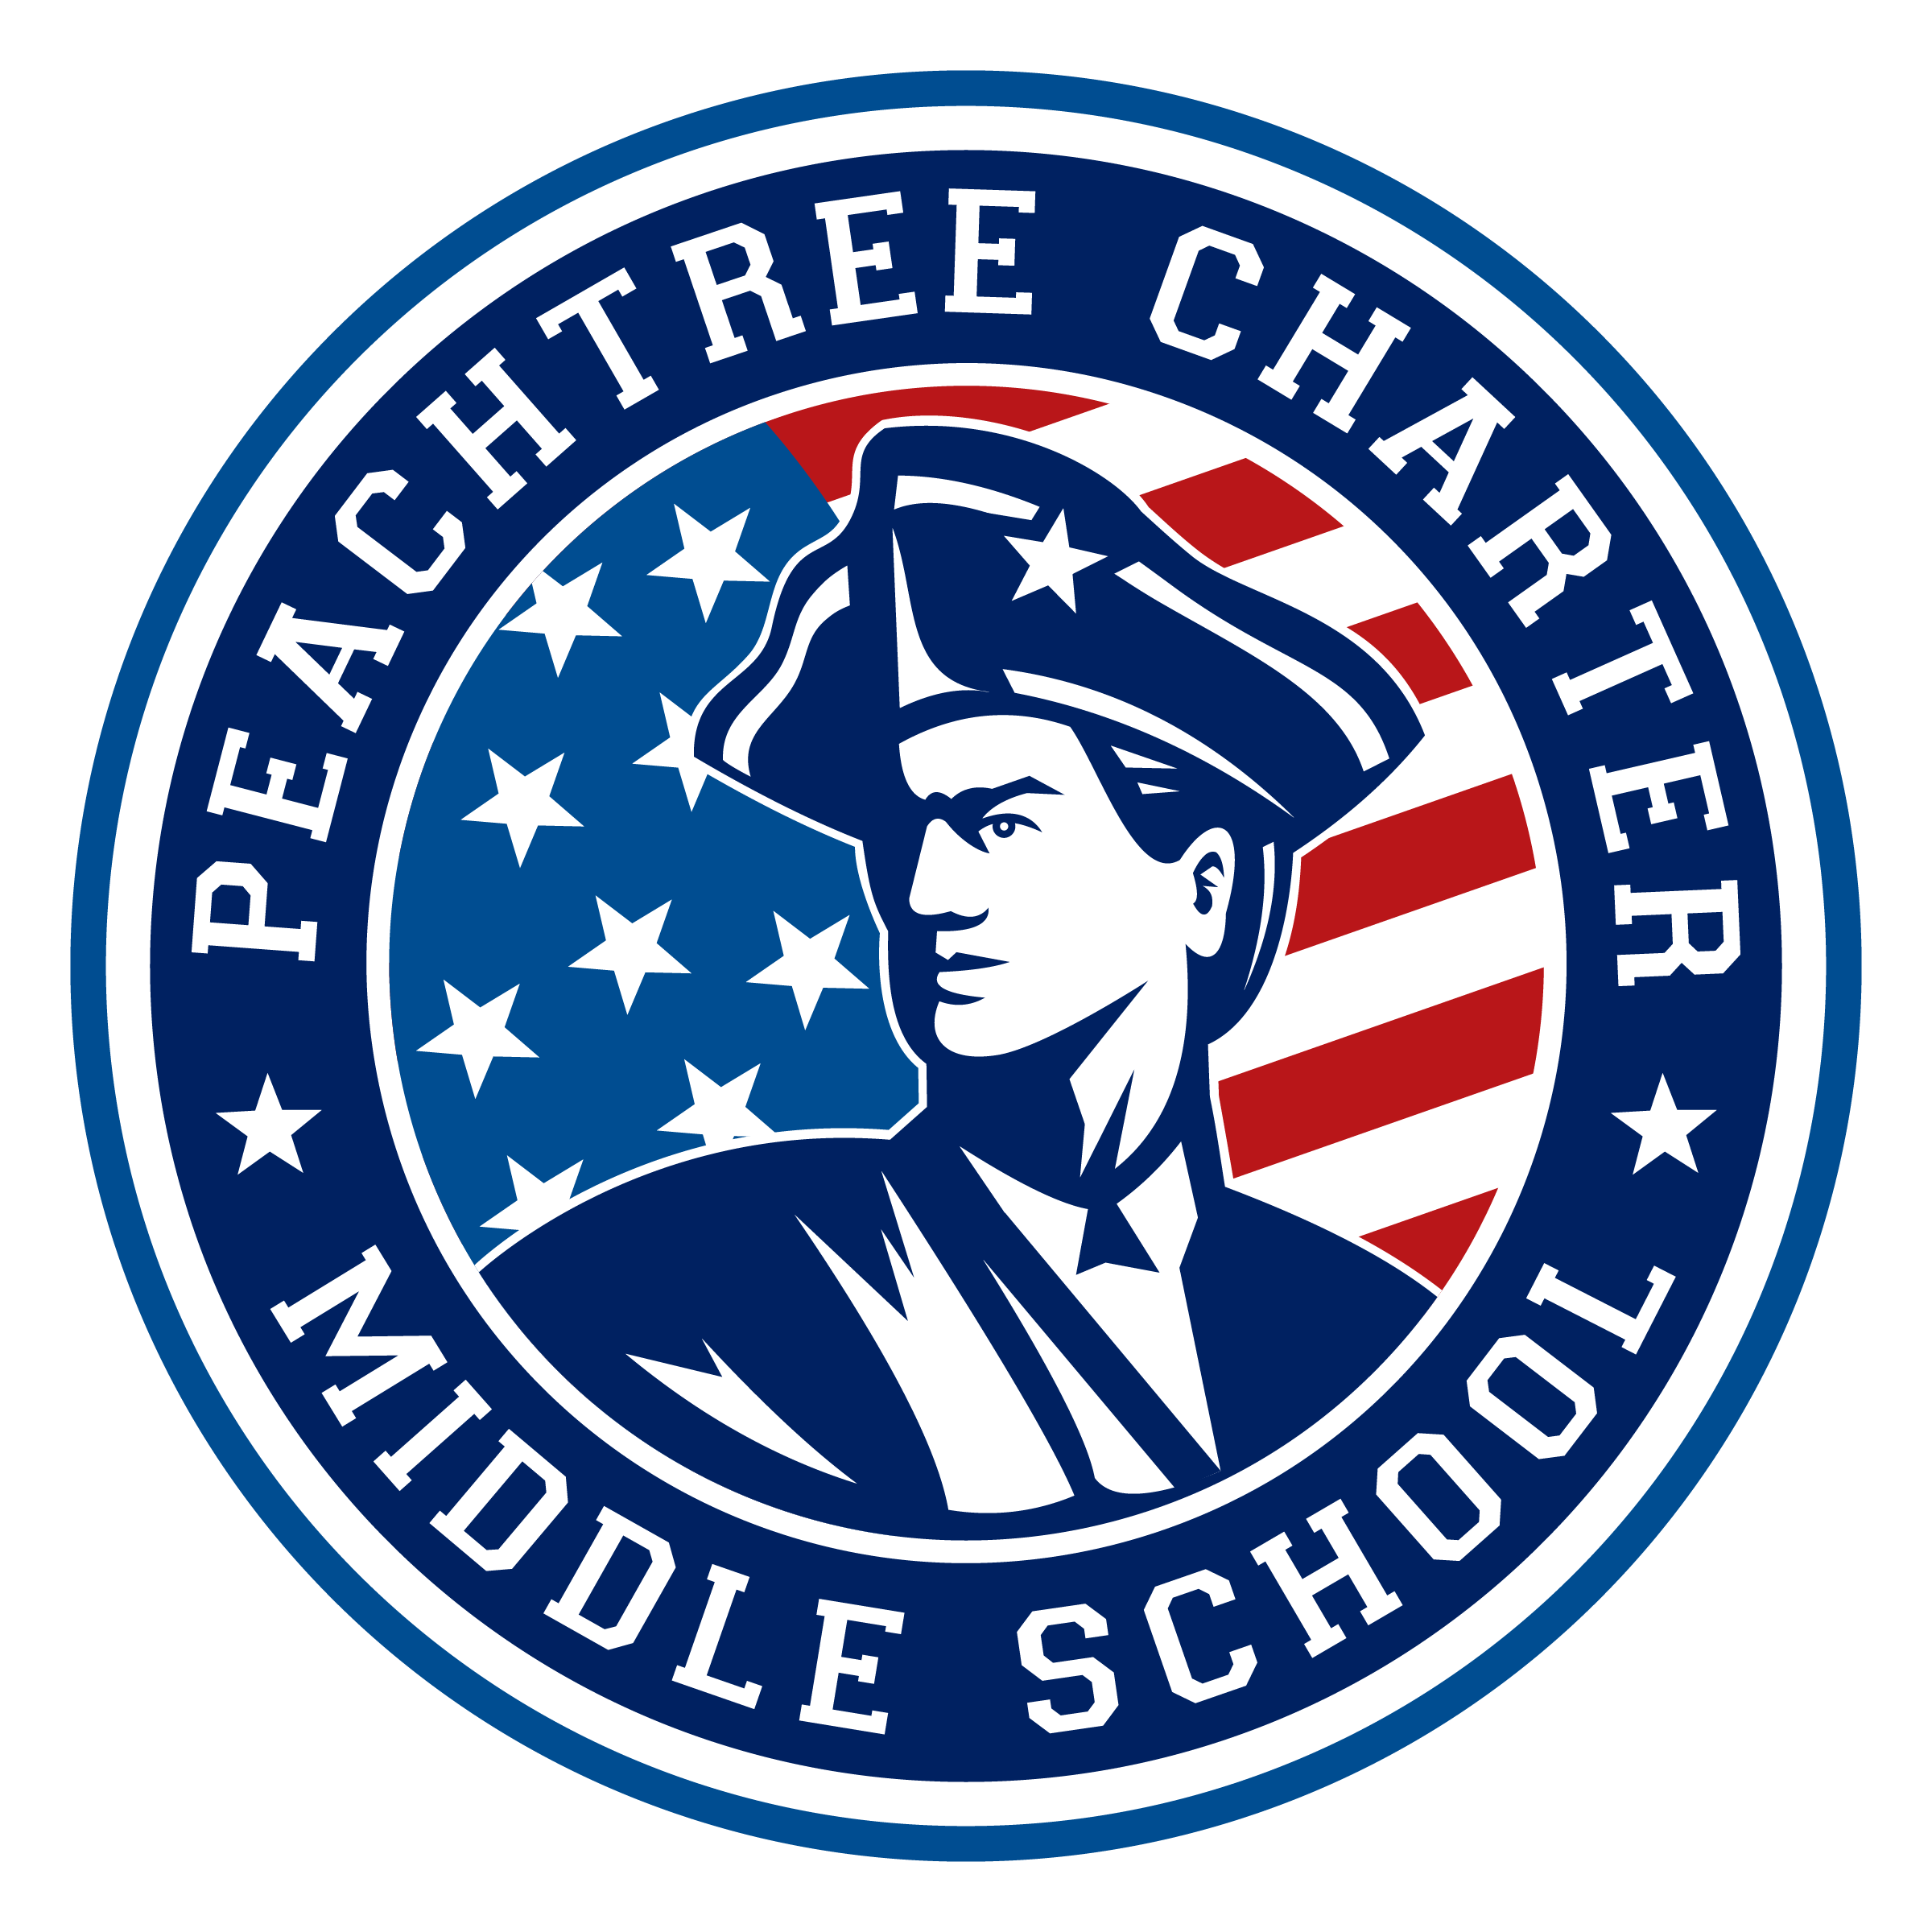

PCMS Governing Board General Meeting Minutes

August 20th, 2020
6:30 pm – Zoom Virtual Meeting

Meeting called to order by Erika Harris: 7:04pm
- Public Comment (3 minutes each): None
- Co-Chair Report: Erika Harris congratulated PCMS on a strong start to virtual learning and shared that there was overall great community feedback re: PCMS’s first two weeks of school.
- Approval of July Minutes: Jenny Schiff asked for the minutes to reflect that she is a Teacher Rep on the GB and not a guest attending the meeting in August. Minutes passed unanimously with the recommended amendment.
- Action Items from last meeting: Not Reviewed
- Financials: David Lower reviewed the financials. He noted that at this point there was little report, but believed that teachers would likely soon begin to submit for reimbursements for classroom expenses. David also shared that the PCTV purchase was made.
- Grant Requests: None for this meeting but a special meeting will be needed to vote on a grant request for Padlet. Last year’s Director of Finance, Kris Mamaghani, shared that the Director of Finance and the Principal have the discretion to bring a grant directly to the governing board for a vote, that it does not “have” to start in the finance committee. The board was also reminded that any grant request that exceeds $1,000 must be presented to the board by the grant requestee.
- Principal Report: Ms. Allen shared kudos all around for a successful start to the school year. An update was given on laptops being passed out for 6th grade students. Lap tops were being prioritized first for economically disadvantaged students and for those students without personal devices at home.
- Committee Reports
A. Academics: (Written report provided by Director Pam Rock)
In our July meeting, we discussed how the classes were scheduled this year and Ms Perez explained to us that the HA (students who scored 75th percentile and above in both reading and math) were placed into Gifted Classes this year. The rest of the students were placed in grade level classes. She explained how PCMS classes receive funding and how the HA sections have zero funding. She also did a very thorough scheduling presentation to Erika, Ms Schiff and I the following week to explain the scheduling process in detail. We started discussing virtual learning but there was not as much information yet. Ms Perez did discuss the virtual hub being created on the PCMS website. We discussed the new agendas and her hope to do a trunk pick up to distribute agendas plus whatever other materials needed to help organize during virtual learning. Our goals for the year are related to the transition of PCMS to a strategic waiver system pilot program. We will be building out a subcommittee who will partner with Kina Champion and DCSD. We will continue to look at the CSIP goals as they match the goals in our charter. We will work with Amanda Lower and cultural arts and how to implement this in our virtual world.

In our August meeting last Thursday, Ms Perez explained that we are fully staffed for this school year with a star substitute. She discussed the packets that will be available for students until they get their chromebooks. We discussed a lot about open house and came up with some ideas on how to make it fun and unique in this virtual world. Amanda gave us a cultural arts update and is using prezi to make an arts passport card. Each month a different link will come out that kids can go on to. Finally, Erika discussed our meeting with Kina Champion to build out a subcommittee for the transition to the strategic pilot program. We will be having a meeting in September with Ms. Allen, Kina and Ms Perez to get the overall picture, goals and waiver process initiated.

B. Facilities & Hospitality: Director Kim Di Paolo said Facility and Hospitality meetings will follow the week after Governing Board meetings.
C. Finance: Director David Lower shared that the Annual Fund was currently on pause to allow for the school year to start, to follow suit of DHS, and to also be respectful of the economic impact on our PCMS families caused by the pandemic. The goal is to start the annual fund soon, but to be purposeful in our marketing and messaging. The CV Classic is moving forward, but will be a virtual run this year.
D. Regulatory: Director Rebecca Siegel asked that all board members please return the board documentation to her. First meeting will be on Septmeber 9th. Rebecca has been in contact with Shakina Champion and the election of the PCMS PAC is looking good for Spring of 2021. This plus the Principal Search will be discussed in the upcoming regulatory meeting.
- Old Business & New Business
  - DCSD COVID 19 Update & Virtual Learning (T. Allen): So far, outside of a few expected bugs, the virtual kickoff has been a success and thanks was given to Ms. Perez and the supporting leadership team for helping make this happen. The district still continues to monitor the spread of the virus, for now we remain in virtual learning.
  - Open Community Member Positions (E. Harris): Two positions are available. Interested candidates are to submit their interest by email to Erika Harris with a short bio by September 10th. The board will vote on the nominees in the September governing board meeting.
  - Governing Board Student Leaders Opportunity Discussion (D. Lower & E. Harris): David Lower shared that in his August Finance meeting a 6th grade student joined the meeting with her mother. Even after having their general question answered (not related to finance, but they joined the meeting because they hoped an answer could be found there) the student stayed for the entire meeting. David and Erika discussed how inspiring having her presence was and how it helped keep the focus and reminder of the work we do clear. As PCMS moves forward with the Pilot Program, the district looks for student engagement in decision making and leadership. It was discussed that creating positions for students to act as ex-officio members on the board could help to build student leaders at the school and also strengthen our stakeholder engagement in building the pilot program. The board briefly brainstormed how this might look, ex: students could be nominated by teachers, allow opportunity for students who often fly under the radar to be included, etc. Betty Dominguez, David Lower, Michelle Perez, our teacher reps, and Alethia Crowder will work to build the bones of this program and present to the Governing Board in September/October.
  - PCMS Governing Board – Learning Together: Being Anti-Racist (D. Lower): David Lower presented the 21 Day Racial Equity Challenge to the board and suggested that it could be a good opportunity for our governing board to explore together as we purse inclusion as a school goal. API Michelle Perez expressed great interest in this, and suggested it could even expand beyond the board to staff in-service opportunities. Because of time, this agenda item will be continued in the September meeting and David Lower will send out information about the program for the board to read.
  - PCMS Governing Board 2020-2021 Priorities Monthly Update
    - Building a PAC (Regulatory): See Regulatory report. More information coming.
    - Building a PTO (Facilities & Hospitality/Finance): Director Kim Di Paolo is very excited about this program. She shared that a subcommittee will be created to build the new PTO and more information will be coming soon.
    - PCMS Strategic Waiver System Pilot Program (Academics): See Academics report. Pam Rock, Erika Harris, Principal Allen, and API Perez will meet with Ms. Shakina Champion (Director of the DCSD Department of Innovation) in September. More information will be coming.
XII. Adjournment: 8:57pm
Next Meeting: September 17th, 2020
Meeting Norms

1. Maintain a focus on what is best for our students.
2. Show respect (never dismiss/devalue others).
3. Be willing to compromise.
4. Disagree (when necessary) agreeably.
5. Make a commitment to effective deliberation, each one listening with an open mind while others are allowed to express their points of view.
6. Participate by building on the thoughts of a fellow Board member.
7. Make a commitment to open communication and honesty.
8. Commit the time necessary to govern effectively.
9. Be collaborative
10. Maintain confidentiality (which leads to the building of trust).
11. Look upon history as lessons learned; focus on the present and the future.

