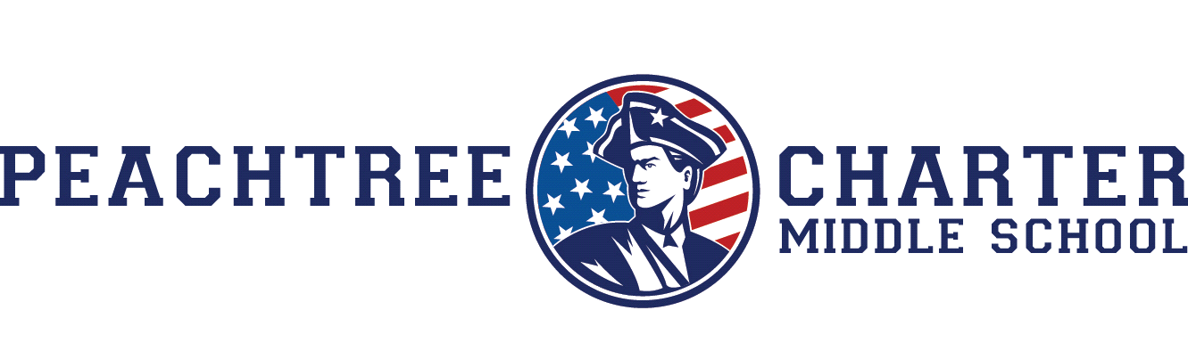
PCMS FOUNDATION
ACADEMICS AND CURRICULUM COMMITTEE
September 26, 2017
7:30am Call to order
7:35 am Approval of minutes 8/22/18
7:40am Topic discussion
a. Extended school day
b. Summer work
c. Staff accountability/parent partnership policy review
d. STEM certification (science fair)
e. New curriculum
8:25am Identify topics for future meetings
a. Continuous Improvement Plan
b. Budget and FTE spending
c. Additional topics
8:35am Adjourn

