 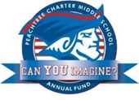

PCMS Foundation Board of Directors Meeting

Agenda, Thursday March 16, 2017

Welcome Johnson

Public Comment- 3 minutes each

Approval of Minutes from February 2017 meeting Sacks

Approval of Minutes from Special Called Meeting (3/2/2017)

Review of action Items

Reorganization

Merger of PTCC and Foundation Johnson

Financials Guven

Principal’s Report Heptinstall

Grant requests

Update on capital purchases/delivery/usage

PTCC Update LeDoyen

Adjournment

Next Meeting: Thursday April 20, 2017