 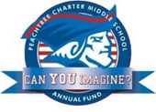

PCMS Foundation Board of Directors Meeting

Agenda, Thursday November 17, 2016

Welcome Johnson

Members and Guests

Approval of Minutes from October 2016 meeting Sacks

Review of action Items

Financials Guvan

Grant Procedure-Final Etheridge

Committees

Capital purchases Johnson

Principal’s Report Heptinstall

Intramurals

Grant requests

PTCC Update LeDoyen

Old/New Business Johnson

Land Swap DCSD and City of Dunwoody

Adjournment

Next Meeting: Capital Purchase Discussion: Thursday Dec 8, 2016 at 7:30 am