 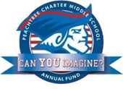

PCMS Foundation Board of Directors Meeting

Agenda, Thursday September 15, 2016

Welcome Johnson

Members and Guests

Approval of Minutes from August 2016 meeting Sacks

Financials Guvan

Principal’s Report Heptinstall

Update

Grant requests

PTCC Update LeDoyen

Committees

Projects:

Grant follow-up Etheridge

Capital purchases Johnson

Corporate Sponsors Urtusastegui

Corporate Matching Johnson

STEM Wassell

Old/New Business Johnson

Board training

Next Meeting: Thursday October 20, 2016 at 7:30 am

Adjournment